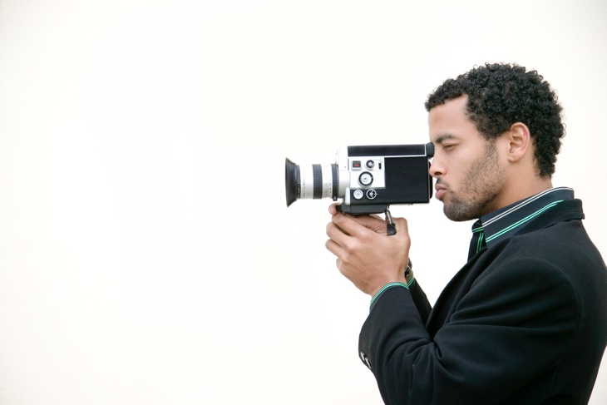**Journalism 370**

**Digital Media in Journalism**

**Class Time:** 9-10:50 a.m. Tuesdays & Thursdays

**Classroom:** CF 202 **Instructor:** Stephen Howie

**Contact Info:** 304 Arntzen Hall 360-650-2561 [Stephen.Howie@wwu.edu](mailto:Stephen.Howie@wwu.edu)

**Office Hours:** 12-2 p.m. Monday, 12-1 Tuesdays & Thursdays

**REQUIRED VIEWING**

* [**Media Storm**](http://www.mediastorm.com/) **(Login: Stephen.Howie@wwu.edu Password: Jour370)**
* [**California is a Place**](http://californiaisaplace.com/cali/)
* [**NYT Op-Docs**](http://www.nytimes.com/video/op-docs/)

**NECESSARY EQUIPMENT**

# External Hard Drive (Can be checked out for entire quarter from Classroom Services)

* Access to a digital video camera or DSLR (Can be checked out for 24 hours or for the weekend - Friday to Monday - from Classroom Services)
* Headphones (bring to class every day)

**Course Description**

In this course, students will learn the basic steps to plan, produce, edit and publish videos that combine written components, audio and graphics to create compelling multimedia reports. Students will watch, analyze and critique published multimedia projects. Students will produce, edit and publish final projects that combine written, audio and visual elements.

Final projects will be published on [the class website](http://www.digitalmediainjournalism.com/). Students will write accompanying text to explain their projects.

**Course Objective**

This course consists of lectures, video screenings, class discussions, in-class critiques, presentations and hands-on learning.

**Upon completing this course, students should understand how to:**

* Write for multimedia – both in terms of narration and text.
* Plan and prepare for multimedia projects.
* Produce and edit audio and visual components.
* Color correct and audio master multimedia projects.
* Critically analyze the production of published videos.

**Video Projects**

Projects will be edited in Final Cut Pro X or in Adobe Premiere and stored on external hard drives. Bring your hard drives to class so you always have access to your files. Drafts and revisions of your videos will be submitted on Canvas as .mov or .mp4 files.

In addition to working on your own video project, you are required to crew for two other people in class, helping them set up and conduct interviews and/or collecting B-roll footage.

All video footage for this class must be taken using a tripod or a motion device, such as a slider, dolly or steady cam. **Handheld footage will not be accepted.**

**Grades based on: Possible points**

* **Attendance**  **10**
* **Participation**  **10**
* **In-Class Exercises & Homework** **20**
  + Elevator Pitch
  + Video Portrait
  + Captured Moment
  + Motivated Action
  + Video Sequence
  + Motion Exercise
  + Interview Practice
  + Faculty Interview
  + Audio Exercise
  + Individual Project Sequence
* **Team Support 10**
  + Crew For at Least Two Classmates (Interview & B-Roll)
* **Individual Project** 
  + Proposal **5**
  + Interview Transcript  **3**
  + Interview Shaped as Story  **2**
  + Radio Edit **5**
  + Rough Cut  **5**
  + Interim Cut **10**
  + Final **20**

### Total: 100

**Late Work** is graded down 10 percent per day.If you must miss class for a legitimate reason, I must be informed via Canvas or email before the missed class.

j0370548**Attendance** is mandatory. Missing class will adversely affect your grade. Arriving in class late also will affect your grade. (Two lates equal one absence.) If you miss six or more classes, you will be in danger of failing the course.

**Plagiarism:** If I catch you taking someone else’s work and trying to pass it off as your own, I will fail you for the assignment. If I come to the conclusion that the plagiarism was intentional, I will consider failing you for the course. See [the WWU Web site](http://www.wwu.edu/integrity/) for more.

**Computer Lab Etiquette:** I know it is tempting to check your e-mail, go online or conduct other school and personal work during class. But if I catch you doing this, I will count you as absent for the day.

**Accommodation:** Reasonable accommodation for people withdocumented disabilities should be established within the first week of class and arranged through disAbility Resources for Students: 650-3083, [drs@wwu.edu](mailto:drs@wwu.edu) or [www.wwu.edu/depts/drs/](http://www.wwu.edu/depts/drs/)

**Classroom Environment:** Mutual respect for everyone is key to ensuring a safe environment that promotes learning for all students. Western encourages students to seek assistance and support at the onset of an illness, difficulty, or crisis.

Your behavior in the classroom should mirror the standards of a journalist in a professional environment. Interrupting classmates or instructors, sleeping, using cell phones or text messaging during lectures, unrelated use of the Internet during class, or using deliberately offensive language all fall short of accepted professional standards. When listening to or working on projects in class, please use headphones and be respectful of others.

Be ready to learn at the start of class. Offer your full attention during lectures and when others are presenting their work.

**Technical Training:** This class covers introductory technical aspects related to creating multimedia projects, from camera settings, to lighting, audio, and video editing.While there will be a fair amount of technical instruction, much of the emphasis will be on the storytelling and the content of your projects. You will need to take initiative to explore and learn additional technical aspects of multimedia storytelling outside of class, as well. Help each other out in class and in labs. Seek out resources to gain knowledge and expertise. Take advantage of workshops and other training opportunities available to you through [Student Technology Services](https://stc.wwu.edu/workshops).

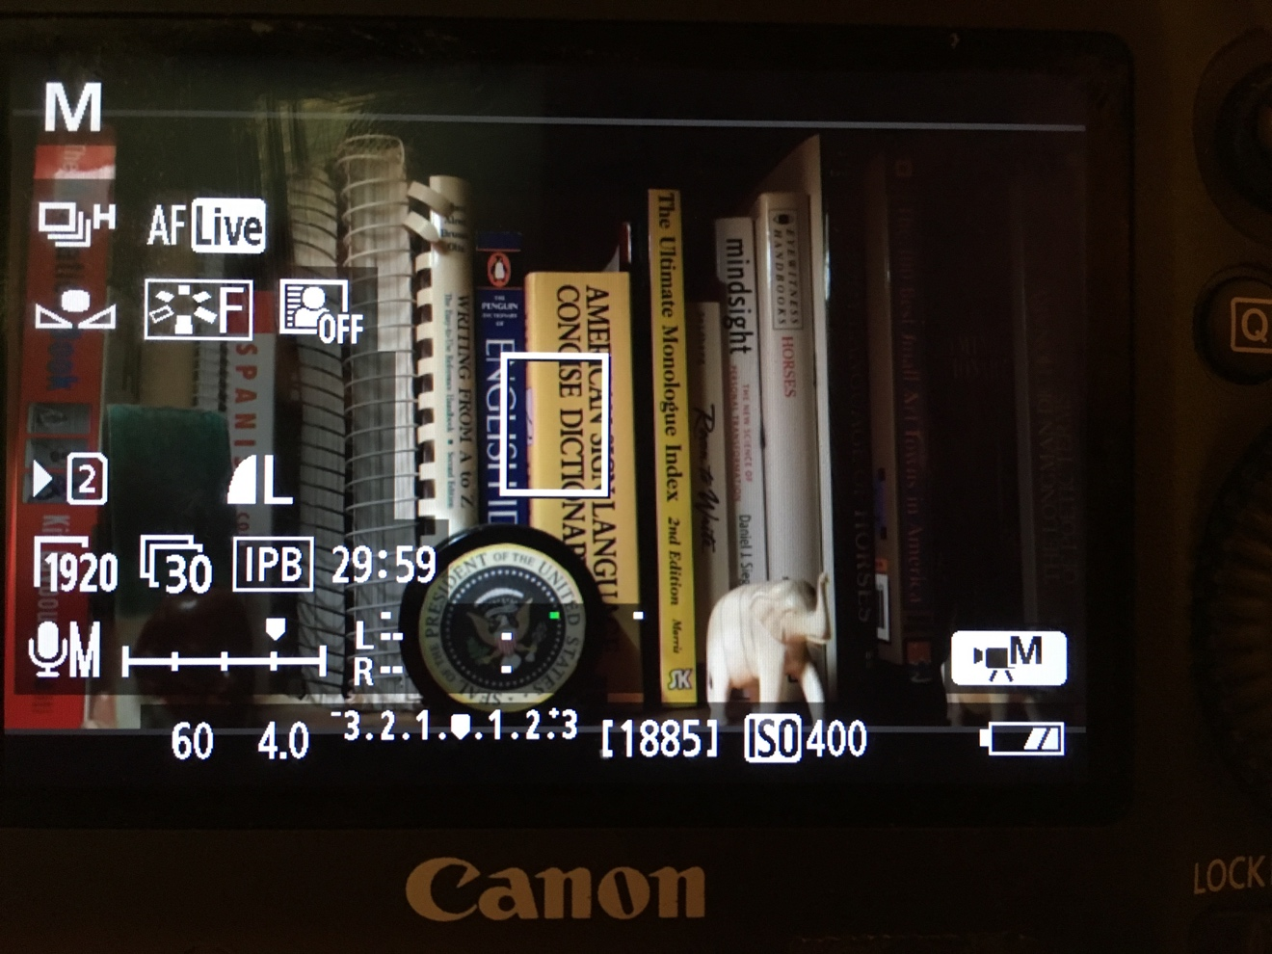

**J370 • Digital Media in Journalism • Course Schedule**

*This course schedule is subject to change. Changes, if any, will be announced in class and on Canvas. Students will be held responsible for all changes.*

**WEEK 1 • METHODOLOGY & VIDEO BASICS**

**Tuesday, April 2:** Introductions, syllabus review. Discuss narrative arc. Review Media Storm methodology. View project examples from previous quarters. Visit classroom services.

* **Homework:** **Come up with ideas for project.**

**Thursday, April 4:** Review video basics and camera settings. Discuss project ideas.

* **Homework:** **Shoot Video Portrait. Write Elevator Pitch.**

**WEEK 2 • PORTRAITS & MOMENTS**

**Tuesday, April 9:** View/discuss Video Portraits. Intro to video interview techniques. **Due: Video Portrait, Elevator Pitch.**

* **Homework: Capture a Moment.**

**Thursday, April 11:** View Captured Moments, Create Practice Sequence.

* **Homework: Project Proposal.**

**WEEK 3 • PRE-PRODUCTION**

**Tuesday, April 16:** Audio Exercise. **Due: Project Proposal.**

* **Homework: Audio Moment.**

**Thursday, April 18:** Discuss Two-Camera Interview, Three-Point Lighting. **Interview Practice Exercise.** Watch / Critique interviews.

* **Homework: Motivated Action Exercise.**

**WEEK 4 • INTERVIEW SETUP**

**Tuesday, April 23: Faculty Interviews.** Review footage. **Due: Motivated Action Exercise.**

* **Homework: Complete Video Sequence.**

**Thursday, April 25:** Editing Basics. **Due: Video Sequence.**

* **Homework: Project Interview.**

**WEEK 5 • MOTION**

**Tuesday, April 30:** Motion Day • Work with Sliders, Dolly w/ Tracks, Steady Cams.

* **Homework: Transcribe Project Interview, Motion Exercise.**

**Thursday, May 2:** Shaping transcripts into a narrative arc. **Due: Interview Transcript, Motion Exercise.**

* **Homework: Shape Transcript into Story, Find music.**

**WEEK 6 • SHAPING THE STORY**

**Tuesday, May 7:** Using music to enhance the emotion of your story. Discuss B-Roll Ideas. **Due: Transcript Shaped as Story.**

* **Homework: Radio Cut.**

**Thursday, May 9:** In-class work on projects. Play Radio Cuts. **Due: Radio Cut.**

* **Homework: Collect B-Roll and Additional Footage.**

**WEEK 7 • TEXT, TITLES & TRANSITIONS**

**Tuesday, May 14:** Watch Project Rough Cuts. **Due: Project Rough Cut.**

**Thursday, May 16:** Adding Text, Titles & Transitions.

**WEEK 8 • STRUCTURE & FLOW**

**Tuesday, May 21:** In-Class Work on projects.

* **Homework: Finish Interim Cut.**

**Thursday, May 23:** View interim cuts. **Due: Interim Cut.**

**WEEK 9 • AUDIO MASTER & COLOR CORRECT**

**Tuesday, May 28:** Color Correction & Audio Mastering. View remaining Interim Cuts.

**Thursday, May 30:** In-Class Work on Projects.

**WEEK 10 • EXPORT & PUBLISH**

**Tuesday, June 4:** Fine-Tuning & Exporting. In-Class work on Project Explainer. Find Still for Thumbnail.

**Thursday, June 6:** Teacher Evaluations & Course Review.

* **Homework: Complete Final Cut.**

**FINALS •** Final projects due by **2 p.m. Tuesday, June 11.**

**NOTE:** Final projects must include titles, typed explanations, credits and a still for the thumbnail on Squarespace.