Clemson University’s Youth Learning Institute

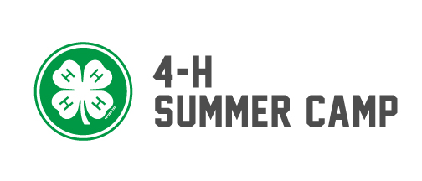
4-H Summer Camp Job Description

Title: 4-H Summer Camp Counselor
Work Dates: May 17th – August 9th, 2020
Location: Camp Bob Cooper, Summerton, SC

Description:
4-H summer camps provide an opportunity to experience new and exciting activities; including climbing wall, archery, canoeing, and many others offered in a safe, supervised environment where campers can explore new areas of interest with encouragement from trained counselors and staff. Counselors lead, instruct, and supervise campers in all areas of summer camp programming. The camp is run out of Camp Bob Cooper in Summerton, SC. Counselors will have the opportunity to work with the following types of camps: 4-H, disability and special needs, diabetics, faith-based, and traditional programs. You can look at our camp by going to our website at http://4hsummer.camp

Principal Duties:
    - Assist in teaching all components of the summer camp program including canoeing, teams’ course, high ropes, climbing wall, recreation, arts and crafts, swimming, tubing, paintball, and archery (training provided).
    - Lead campers in daily program classes and activities (wake-up, flagpole, meals, campfire, and wrap-up).
    - Become actively involved in all program activities, leading and participating in evening recreational and instructional times as scheduled.
    - Assist with routine cleanup.
    - Train in a specialty area to assist as needed with rental group responsibilities.
    - Set-up, maintain, and break down the site and program areas.
    - Perform direct supervision of children while involved in classes and activities.
    - Perform camp counselor duties including staying with and attending to campers over night while they are at camp.
    - Perform duties that are required by Camp Leadership.

Qualifications:
    - Must have a High School Degree.
    - Working toward college degree.
    - Residential camp experience preferred.
    - Must have the patience, understanding, flexibility, and energy to work and live with campers and staff.
    - Must demonstrate teaching skills and the ability to implement creative “hands-on” teaching methods.
    - Must be willing to sacrifice, adapt, and work hard as part of a team pursuing one common goal and objective.

Salary: $440-$580 twice a month plus lodging, meals during camp and a sickness/accidental insurance plan.

Contact: If you are interested in the position please send your resume and three professional references to Candice Heatherly at ceharpe@clemson.edu

Clemson University is an Affirmative Action/Equal Opportunity employer and does not discriminate against any individual or group of individuals on the basis of age, color, disability, gender, national origin, race, religion, sexual orientation, veteran status or genetic information.

